**Adtrain troubleshooting:**  
  
-To check system uptime:  
  
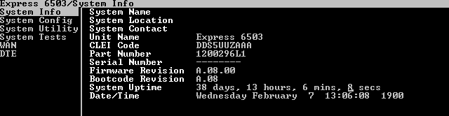  
  
  
To check SNR margin and errors [WAN -SHDSL-status-performance monitoring]  
  
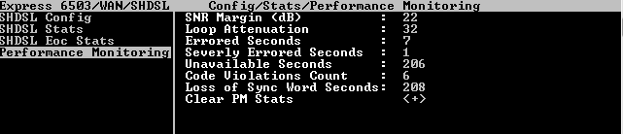  
  
To change clocking and DSL speed [WAN- SHDSL -stats]  
  
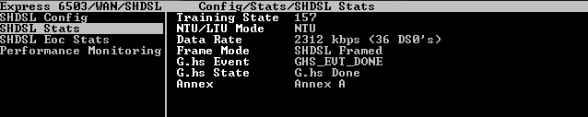

-to check that LMI is physically up [WAN-ATM/Frame – ATM/FR IWF-status –frame relay -port]  
  
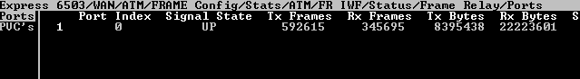  
  
  
  
-To check the LMI status and send /receive frames [WAN-ATM/Frame – ATM/FR IWF-status –frame relay -PVC]  
  
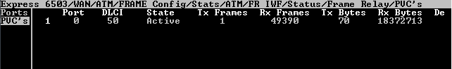

-to check frame relay to ATM mapping [WAN-ATM/Frame – ATM/FR IWF-status –IWF]  
  
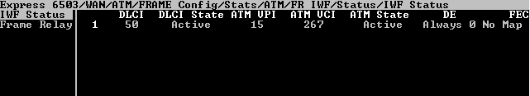  
  
-to check routing table [WAN-IP – IP stats- IP routing]  
  
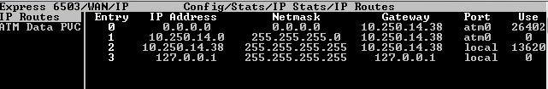  
  
-to change telnet password [system config –telnet user list ]   
  
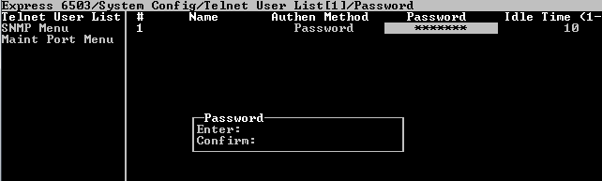

To restart modem remotely [system utility –terminal mode]   
  
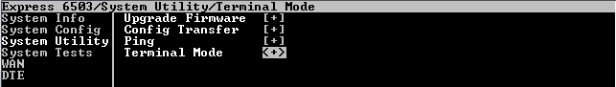  
  
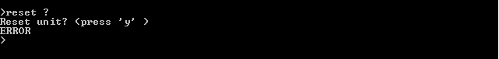  
  
-to use ping utility [system utility -ping]  
  
Note: this utility is used for management only.  
  
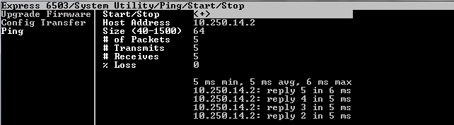  
  
to backup or restore configuration [system utility –configure transfer ]  
  
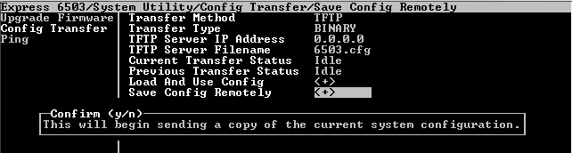

-to upgrade firmware [system utility –upgrade frimware]  
  
